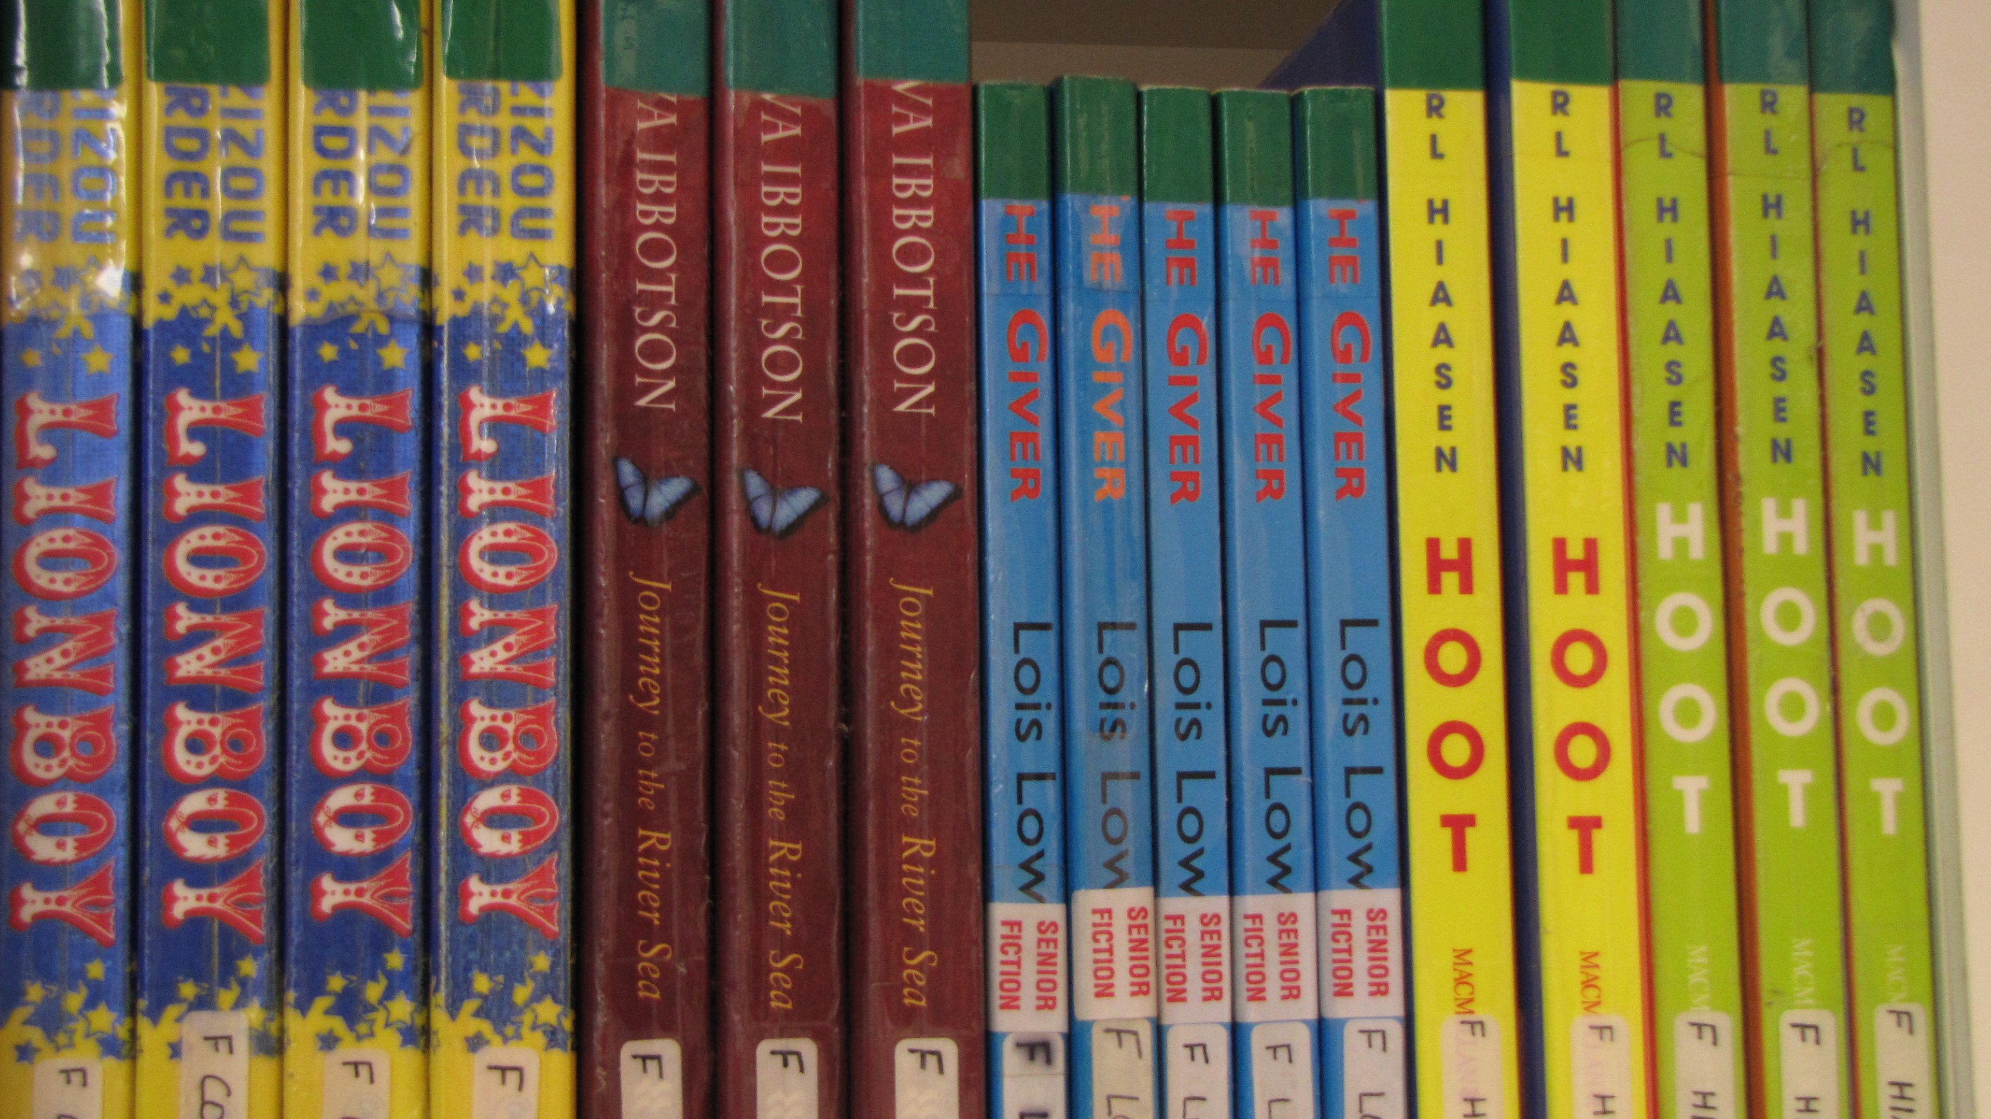

##### GCCC Library Monitors

##### Year 7 - 12

## If you like what you read grab a L.M rego form from the games shelf today and join the L.M team!

G - Godliness

R - Respect

E - Excellence

A - Attitude

T - [Teachability](https://www.google.com.au/search?hl=en&client=safari&rls=en&q=Teachability&spell=1&sa=X&ei=J1pKUZ_2HaTziAfzzIGoDA&ved=0CC8QvwUoAA)

#### G.R.E.A.T

## Your reward

* Go behind the scenes of the library to see how it all works
* Support library staff
* Meet new friends
* Share your love of reading with others
* Unleash your creative talents with displays
* Attend VIP events and the end of year L.M Party

###### L.M Roster

## *Matthew 7:12a*

## *So in everything, do to others what you would have them do to you.*

## 

The library monitor roster is located on the wall in the library foyer.

# Why not consider joining the library team!

We are always looking for enthusiastic students who would like to help out. Here’s what we look for in a Library Monitor. Students who are:

* Reliable
* Respectful
* Trustworthy
* Willing to show initiative

##### **1 Timothy 4: 12**

###### Don't let anyone look down on you for being young. Instead, make your speech, behaviour, love, faith, and purity an example for other believers.

Shelving – Tidying shelves and putting books away in their correct place.

Sorting – Making sure that the books are in order in both fiction and non-fiction.

Displays- Using your creative talents to design library displays

Open Day- Assisting with library activities and events.

Front Desk- Assisting with borrowing and returning books.

### Here’s a list of what you might be asked to do as a library monitor…